Mathematics
An Etoys Number Slate
Kindergarten – First Grade Levels

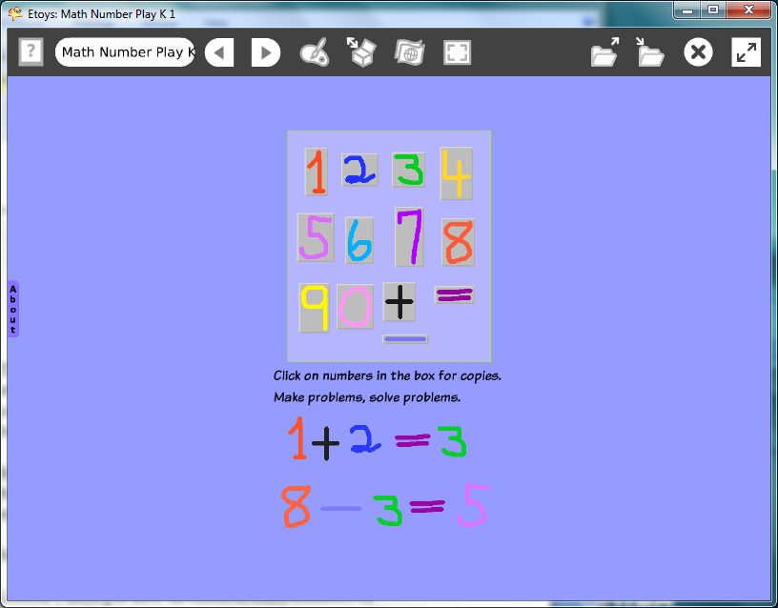

Introduction: | These three lessons use Etoys to make a slate of numbers that students can use in play and in developing mathematical concepts of sets, order, and patterns. It is smart play and beautiful too.
Topic: | Students use Etoys paint tools to draw a set of numbers and basic symbols they will use to explore mathematical relationships and ideas without the use of pencil and paper.
Subject: | Mathematics
Time: | Lesson 1 multiple labs: as children learn numbers or operations, they add it to an on-going project over time  Lesson 2  Lesson 3
Description: | Students use Etoys paint tools from the Navigator flap to draw the set of numbers 0-9. These numbers will be put on a tool called a Maker Button which makes an unlimited supply of each number.  Use the slate for interactive counting, sequencing, and for creating patterns.  Inquiries will occur to students as they draw the numbers. Students may ask, “Where does zero belong?”
Vocabulary: | counting, number names, zero, nothing, pattern, duplicate, copy, set, sequence, above, below, beside, before, left, right, upper, lower, edge, near, up, down, between, almost, add, subtract, equals, exactly
Evaluation Criteria: | Creates patterns of numbers  Knows odd and even numbers  Knows concepts: more than, less than, the same as  Makes a sequence of numbers  Discusses Zero  Gives directions clearly and audibly  Uses complete sentences when giving directions
Teacher Information:  Etoys Quick Guides: Click the question mark in  Etoys to open the set of tutorials about basic tools and techniques. | Etoys Quick Guides: Click the question mark in  Etoys to open the set of tutorials about basic tools and techniques.  Use Etoys Quick Guides if the lesson mentions unfamiliar tools or techniques. Give students time to read them too.
Goals: | Students use the number slates to play with and to explore many mathematical ideas. Students make patterns, describe patterns, describe locations on the screen, relationships between things and develop a vocabulary useful on the screen and in the real world.
Lesson 1:  Two labs  Paint Tools: Brushes  Paint Tools: Color Palette  Navigator Bar: Keep Find Projects | Students will use the Etoys paint tools to draw a number and keep it for future use. After being led through the steps to create the numbers one through four, ask students to discuss what the pattern of steps is. Ask individual children to lead the class through the pattern of steps to make the rest of the set of numbers.  Draw one number.  Click on the paint tools, choose a color, paint a number, and click Keep. Tell students: Make each number small enough to fit on your thumb.  Click Keep when the first number has been drawn to put away the paint tools and leave the finished number on the screen.  Repeat these steps as they draw numbers two through four and then ask students if they know the pattern of steps yet. Discuss.  If they know the steps, ask them to say the steps together as a class for the next few numbers. Or, call on individuals to tell the steps as students make the numbers six through nine. Remind them to use whole sentences when giving directions.  Publish the project name123slatedate; for example: kate123slatefeb07
Extend Lesson 1  Three labs or more | Give students practice at hearing, following, and giving directions. These activities are starting places for exploring ideas and the discussions that students and teachers have are the more valuable part of the idea. These activities could be done with the whole class or by pairs of students.  1. Discuss zero. Is it needed? Why? Should we have started with zero? Should we have ended with zero? Where is it in a number line?  2. Ask students to move numbers on the screen into different orders. For example: 4, 5, 8 “Put the number four on the left side of the screen. Put the five next to it. Put the eight next to the five”. What number is first? What is last? What number is in the middle? Put the 3 above the 4. What is 3+4?  3. Ask a student to choose three numbers and tell the class which numbers, what order and where to place them on the screen. Remind them to use whole sentences when giving directions.  4. Ask how many numbers of each color they have and make a chart on paper in the classroom from that data.  5. Ask what number comes next 3, 4, 5, X. What number comes before the 3?  6. Ask students to put even numbers on the left side of the screen and odd on the other side.  7. Put three numbers above the middle of the screen and the rest below the middle. Where are less than half of the numbers? Where are more than half the numbers?  Note: Do not work quickly; give students time to think and do correctly what is asked. Remind students that the tip of the cursor arrow is what does the work, not the stem.
Lesson 2:  One lab  Navigator Bar: Keep Find Projects  Supplies:  Object Catalog  Object Catalog: Maker Button  Halo Handles: Move and Pick Up | This lesson shows students how to use a Maker Button to provide an unlimited supply of the numbers they made.  Open the project name123slatesate in the folder where it was stored.  Open an Object Catalog in Supplies. Choose the Connectors tab. Drag out enough Maker Buttons for the project. Click the Object Catalog’s X to close it.  Put a number on a Maker Button; the button will grow and turn gray when it has accepted an object. Every time it is clicked on it will give another copy of that number.  Put the numbers in order after they are on the Maker Buttons by using the Maker Button’s black halo handle.  Give students time to experiment with copies and play with their supply of numbers.  Keep the project. There is no need to change the name of the project a version number is added to it for you.
Extend Lesson 2 | Each of these suggestions is an invitation to play and to experiment with the values, colors, and shapes of the numbers. They can be elements in designs, for example a stack of 8’s can look like a chain. These activities could be used with the whole class or by pairs of students.  1. Ask students to make ten copies a number. Make three more copies. Count the copies. How many altogether?  2. Ask students to make a pattern of numbers and/or colors.  3. Ask students to make a pattern that might be hard for someone to find and then show it to one of their neighbors.  4. Ask students to put even numbers on the left side of the screen and odd on the other side.  5. Put three numbers above the middle of the screen and the rest below the middle. Where are less than half of the numbers? Where are more than half the numbers?
Lesson 3  One Lab  Halo Handles: Move and Pick Up  Halo Handles: Size, Color, Copy  Halo Handles: Viewer  Navigator Bar: Keep Find Projects | This lesson shows how to put the Maker Buttons on a Playfield to store them as a set that can be moved on the screen or to other projects where numbers are needed. Students will also create Maker Buttons with plus, minus, and equals signs.  The playfield is in Supplies, click to put one on the world.  Put Maker Buttons with numbers on the playfield. Use the Halo’s Move and Pick Up tool for the numbers on Maker Buttons.  Use the playfield’s yellow handle to make it big enough to hold the whole set of numbers.  Make the world screen and Playfield beautiful.  Open the Script Viewer for the Playfield, click basic, and then choose fill and border.  Click in the green box to open a paint palette and select a color. Experiment with gradient fill.  Use the world’s Viewer to change its color.  Give students time to experiment with numbers and patterns  Keep this project; a version number is added automatically. Students can use this project for many math lesson ideas and for play.
Student Information: | Show students an example project if an LCP projector is available or use a computer and show small groups.
Standards: | Mathematics  Illinois Performance Standards  Kindergarten:  6A, 6B, 6C, 6D Number Work  9B Sorting  10B Data Collection  First Grade:  6A, 8A, 6C, 8C, 10A Visual Patterns, Number Patterns and Counting  Language Arts  Illinois State Goals K-3 Listening  4.A.1a Listen attentively by facing the speaker, making eye  contact and paraphrasing what is said  4. A.1b Ask questions and respond to questions from the teacher and from group members to improve comprehension.  4. A.1c Follow oral instructions accurately.  4.A.1d Use visually oriented and auditory based media  Language Arts  Illinois State Goals K-3 Speaking  4.B.1a Present brief oral reports, using language and vocabulary appropriate to the message and audience (e.g. show and tell)  4.B.1b Participate in discussions around a common topic  National Educational Technology Standards (NETS)  1. Basic operations and concepts  Students are proficient in the use of technology.  3. Technology productivity tools  Students use technology tools to enhance learning, increase productivity, and promote creativity.  Students use productivity tools to collaborate in constructing technology-enhanced models, prepare publications, and produce other creative works  4. Technology communications tools  Students use a variety of media and formats to communicate information and ideas effectively to multiple audiences.
Resources: | Etoys Help Quick Guides: Open Etoys and click the question mark in the Navigator Bar to open a set of interactive tutorials that introduce basic tools and techniques.  EtoysIllinois.org for projects, tutorials, and lesson plans  Squeakland.org Etoys software
kh
April 9, 2012

